**Thiruvalluvar university**

**Periyar ARTS COLLEGE**

**cuddalore – 607001.**



**DEPARTMENT OF COMPUTER APPLICATIONS**

**MACHINE LEARNING WITH PYTHON**

**Project Title :** Optimizing Flight Booking Decisions through Machine Learning Price Predictions

**Team Id :** NM2023TMID35485

**Team Leader :** VIGNESH V(tvu10520CA48)

**Team member:** SURIYAPRAKASH S(tvu10520CA45)

**Team member:** ARUN P(tvu10520CA09)

**Team member:** SILAMBARASAN A(tvu10520CA41)

**Introduction**

This report contains the information about project of Optimizing Flight Booking Decisions through Machine Learning Price Predictions.

**Overview:**

Flight booking decisions can be difficult, with travelers often struggling to balance their budget constraints with their preferred travel dates and airline preferences. Machine learning (ML) can help travelers make more informed decisions by predicting flight prices based on historical data and current market trends.

ML algorithms can analyze large amounts of data from various sources, such as airline websites, travel agencies, and social media platforms, to identify patterns and trends that influence flight prices. By using these patterns, algorithms can make accurate predictions on how prices will change in the future, enabling travelers to make more informed decisions on when and where to book their flights.

With the help of ML-powered price prediction tools, travelers can optimize their flight booking decisions and save money by booking at the right time and choosing the best airline and travel dates for their needs. Additionally, airlines and travel agencies can benefit from these tools by improving their pricing strategies and increasing customer satisfaction.

Overall, the use of ML in flight booking can greatly improve the travel experience for both travelers and businesses, making it easier and more efficient to book flights and travel to new destinations.

**Purpose:**

The purpose of using machine learning for optimizing flight booking decisions through price predictions is to help travelers make more informed decisions about their flights, leading to cost savings and a better travel experience. The project aims to provide accurate predictions of flight prices based on historical data and current market trends, which can help travelers determine the best time to book their flights and choose the most cost-effective travel dates and airlines.

The use of machine learning in this project also benefits airlines and travel agencies by enabling them to optimize their pricing strategies, increase customer satisfaction, and gain a competitive edge in the industry.

Overall, the purpose of this project is to leverage the power of machine learning to improve the travel experience for both travelers and businesses, making it easier and more efficient to book flights and travel to new destinations.

**Problem Definition and Design Thinking:**

**Empathy map:**

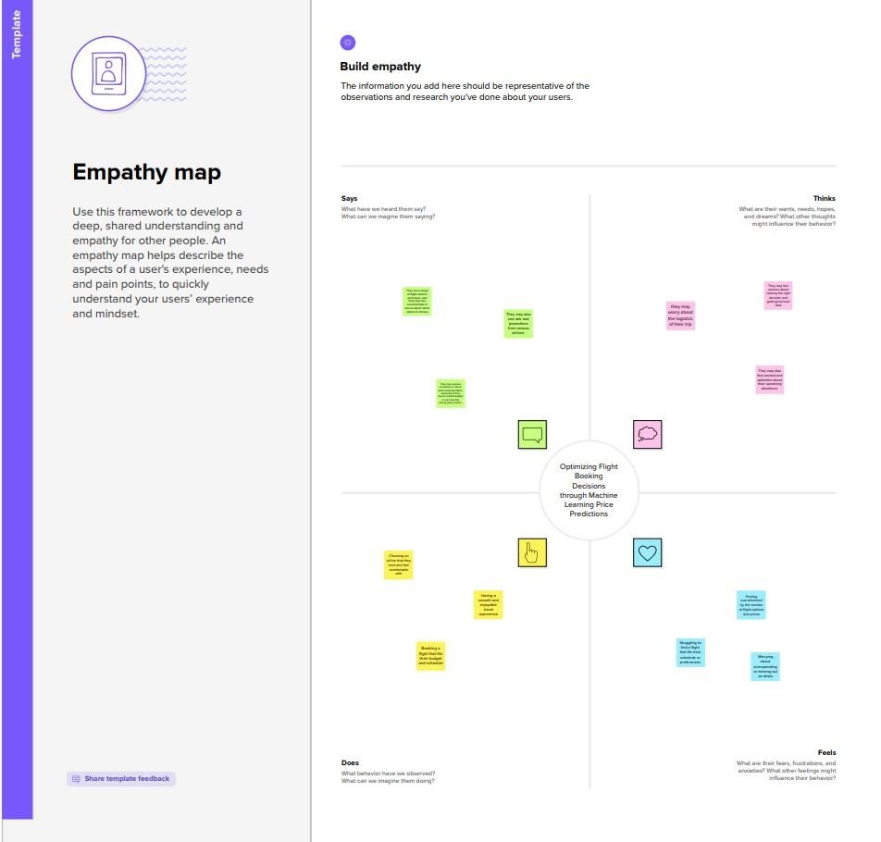

**Ideation and Brainstorming :**

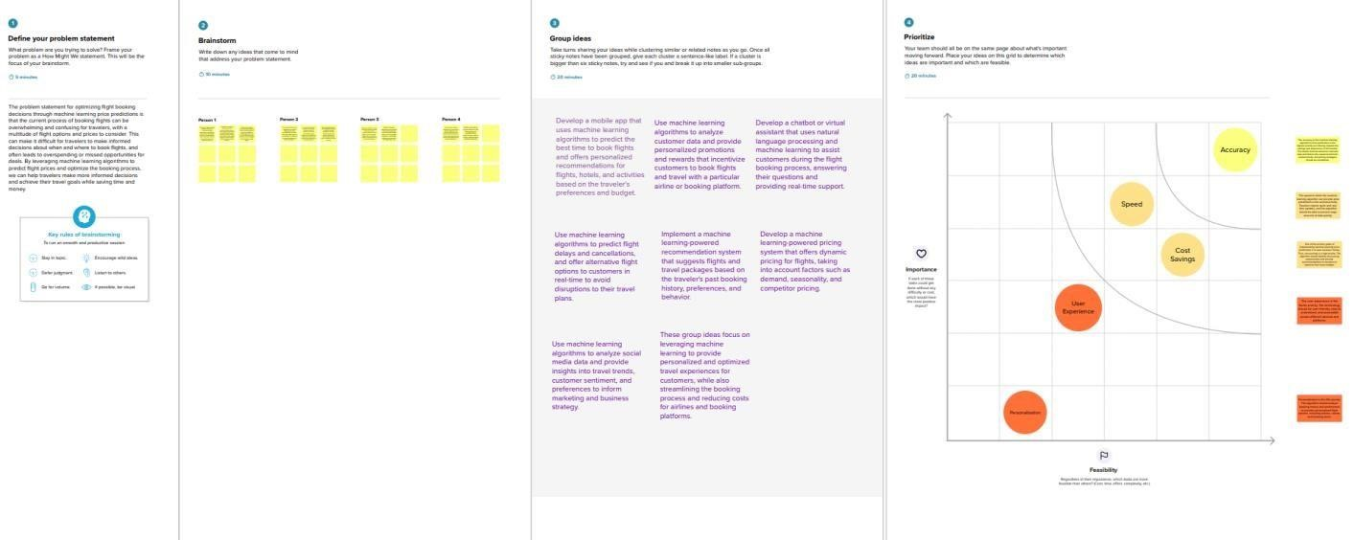

**Result:**

The use of machine learning for optimizing flight booking decisions through price predictions has the potential to revolutionize the travel industry. By analyzing large amounts of data from various sources, machine learning algorithms can make accurate price predictions and help travelers make more informed decisions about their flights.

# Output: (final findings)

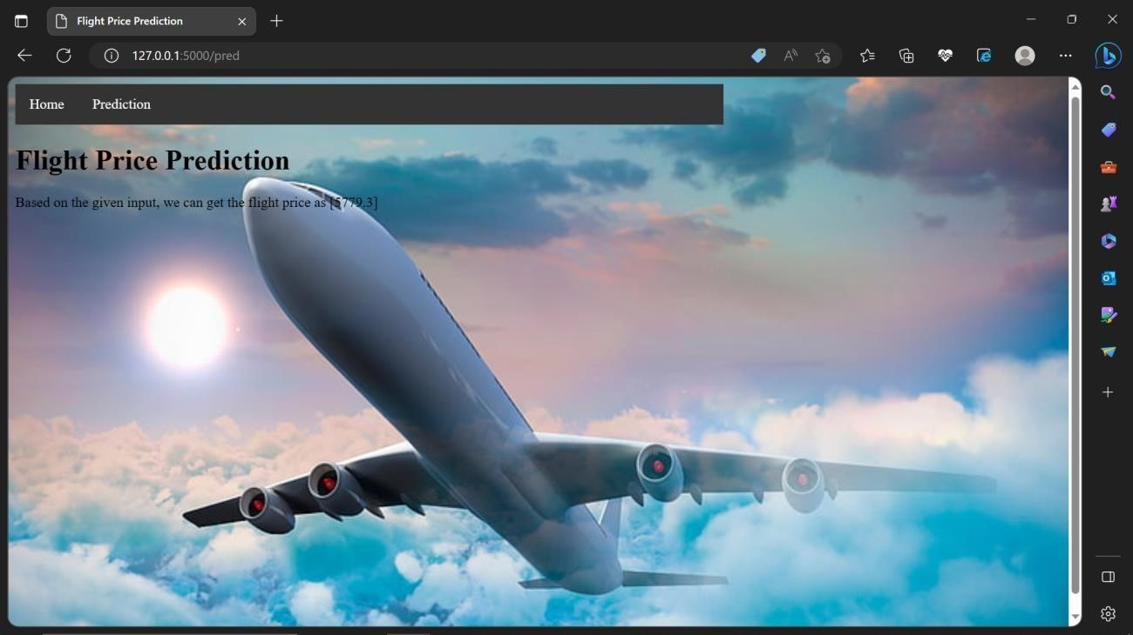

**Advantages:**

* **Accuracy:** Machine learning algorithms can analyze vast amounts of data and identify patterns that may not be obvious to human analysts. This can lead to more accurate price predictions, helping travelers make more informed decisions.
* **Time-saving:** Machine learning algorithms can quickly analyze data from various sources and provide realtime price predictions, saving travelers time and effort.
* **Cost-saving:** Accurate price predictions can help travelers save money by booking flights at the right time, reducing the cost of air travel.
* **Customization:** Machine learning algorithms can consider individual preferences and travel habits, providing customized recommendations to travelers.

**Disadvantages:**

* **Data accuracy:** Machine learning algorithms rely on accurate and up-to-date data to provide accurate predictions. If the data used for training the algorithm is incomplete or inaccurate, the predictions may be unreliable.
* **Technical expertise:** Developing and implementing machine learning algorithms requires technical expertise and resources, which may be a challenge for smaller companies or individuals.
* **Unforeseen events:** Machine learning algorithms cannot predict unforeseen events, such as natural disasters or political unrest, which can affect flight prices.
* **Privacy concerns:** The use of personal data for machine learning algorithms may raise privacy concerns, and companies must ensure they comply with relevant regulations and protect customer data.

**Applications**

The application of this project is in the travel industry, particularly in the areas of online travel agencies, airline websites, and travel search engines. By implementing machine learning algorithms for flight booking decisions, companies can provide their customers with more accurate and personalized recommendations for flights, resulting in cost savings and an enhanced travel experience.

This also extends to airlines and travel agencies, as they can use machine learning algorithms to optimize their pricing strategies and improve their revenue management. By analyzing data on customer behavior and market trends, companies can adjust their prices in real-time to attract more customers and increase profitability.

By using machine learning algorithms to analyze data from multiple sources, companies can provide their customers with more comprehensive travel recommendations and an overall better travel experience.

In travel industry, where machine learning algorithms can be used to optimize flight booking decisions, improve revenue management, and enhance the travel experience for both businesses and customers.

**Conclusion**

By analyzing large amounts of data from various sources, machine learning algorithms can make accurate price predictions and help travelers make more informed decisions about their flights.

The benefits of using machine learning for flight booking decisions include increased accuracy, time and cost savings, customization, and improved pricing strategies for airlines and travel agencies. However, there are potential drawbacks, such as the need for accurate and up-to-date data, technical expertise, unforeseen events, and privacy concerns.

Despite these challenges, the application of machine learning for flight booking decisions is a promising development for the travel industry. Companies that adopt these technologies are likely to gain a competitive advantage by providing better pricing strategies and personalized recommendations to their customers, resulting in increased customer satisfaction and loyalty.

**Future scope:**

The future scope of this project is vast and promising, with the potential to further improve the travel experience for both travelers and businesses.

**Integration with augmented reality:** The integration of machine learning algorithms with augmented reality could help travelers to visualize and interact with their travel plans in real-time, providing a more immersive and personalized travel experience.

**Expansion to other modes of transportation:** The application of machine learning for optimizing travel decisions can be extended beyond flight bookings to include other modes of transportation such as trains, buses, and taxis. This would allow travelers to make more informed decisions about their travel plans and choose the most costeffective and efficient modes of transportation.

**Integration with smart cities:** The integration of machine learning algorithms with smart city infrastructure could help travelers to navigate their destinations more efficiently, providing real-time traffic information, parking recommendations, and other helpful information.

**Personalized travel recommendations:** As machine learning algorithms become more advanced, they will be able to provide more personalized travel recommendations based on a traveler's preferences and past travel history. This would allow companies to offer customized travel packages and improve customer loyalty.

**Increased use of natural language processing:** The use of natural language processing in conjunction with machine learning algorithms could enable travelers to interact with virtual travel assistants using natural language, providing a more intuitive and user-friendly experience.

**Appendix:**

Project (2).ipynb

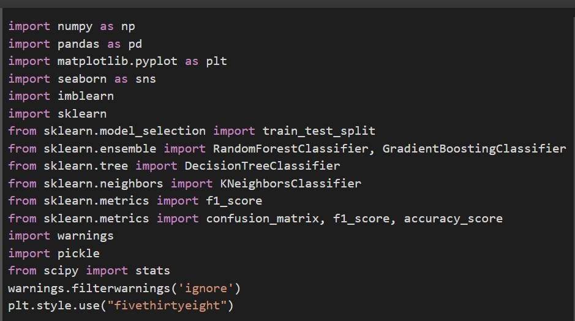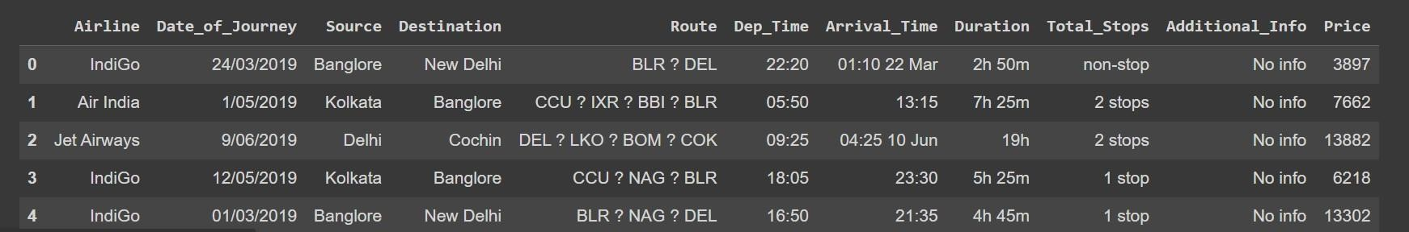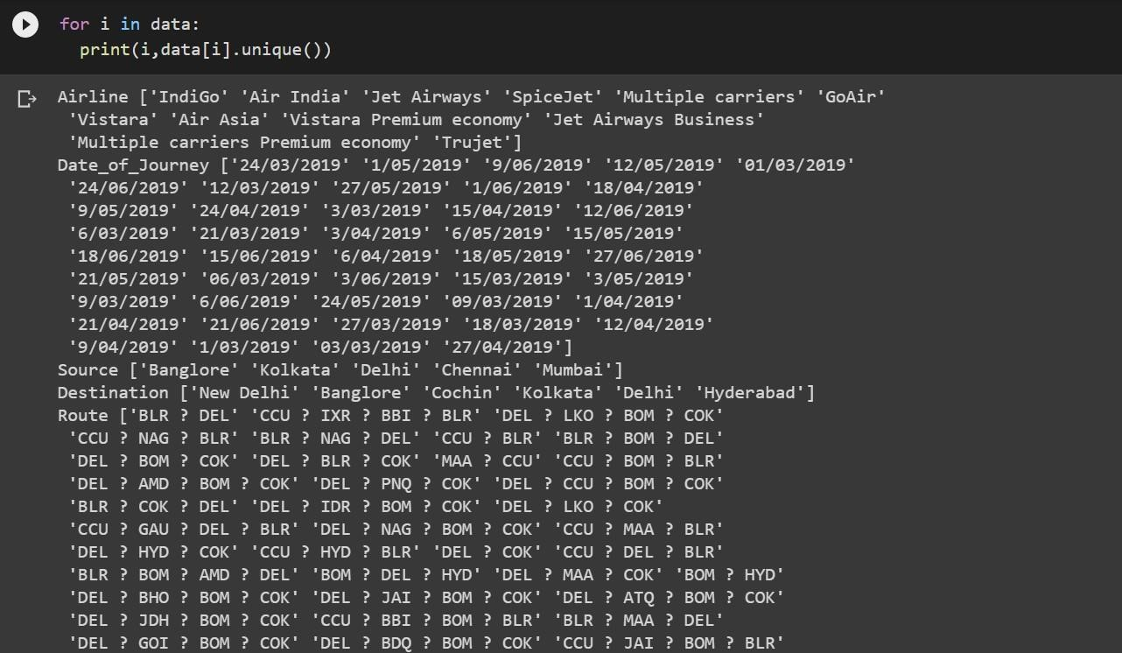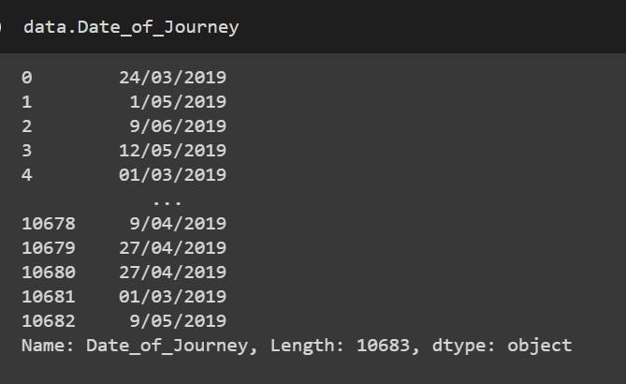

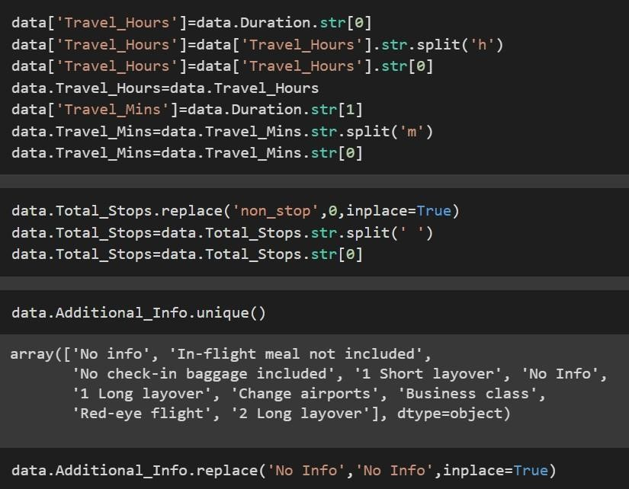

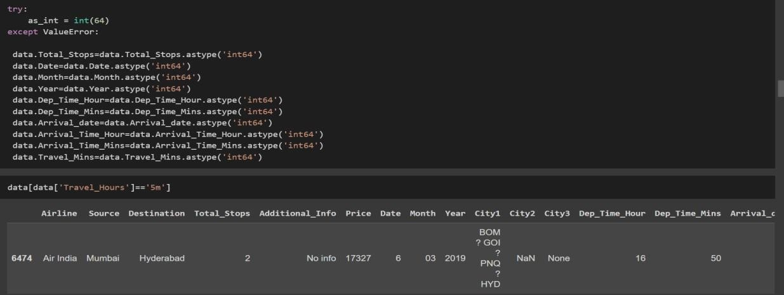

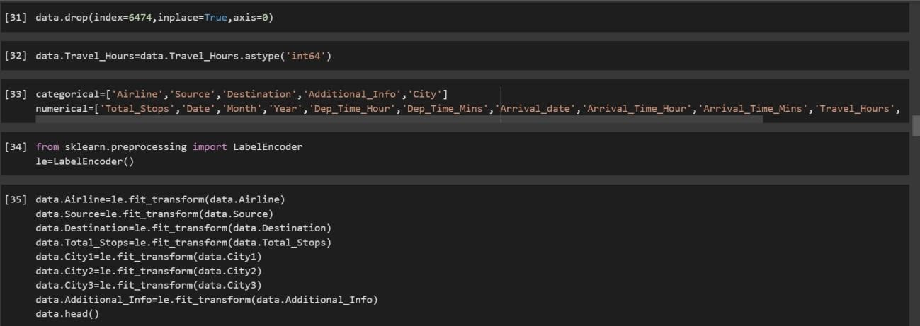

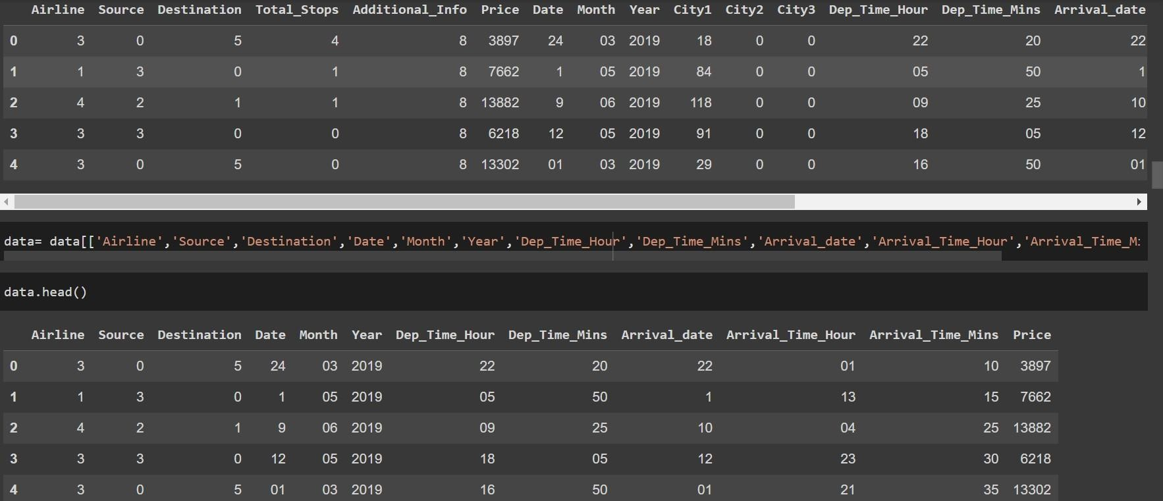

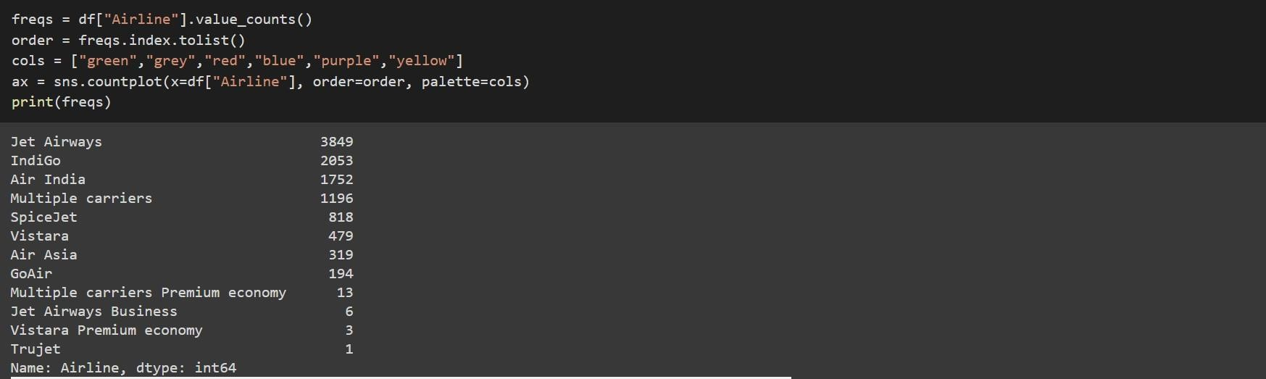

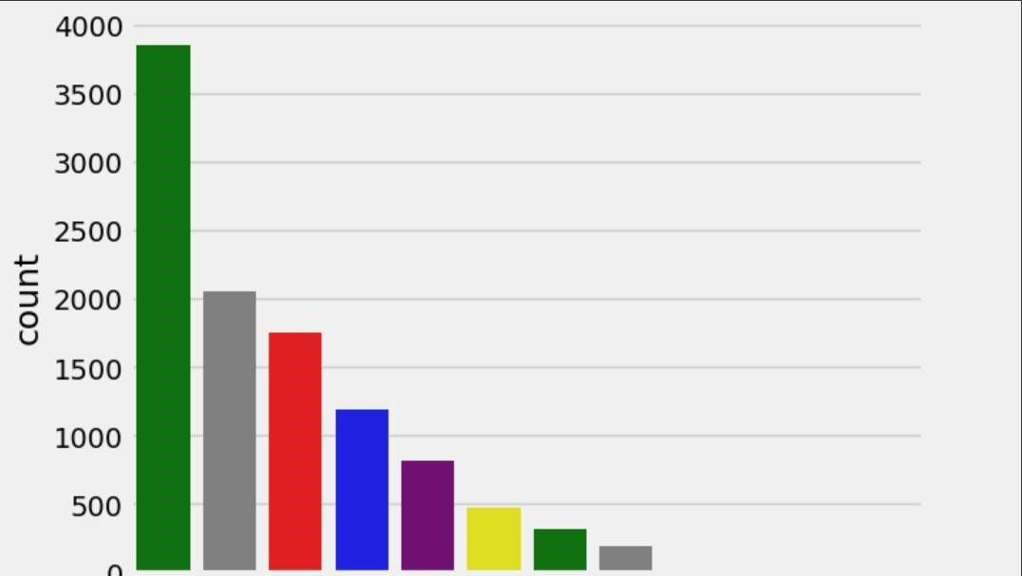

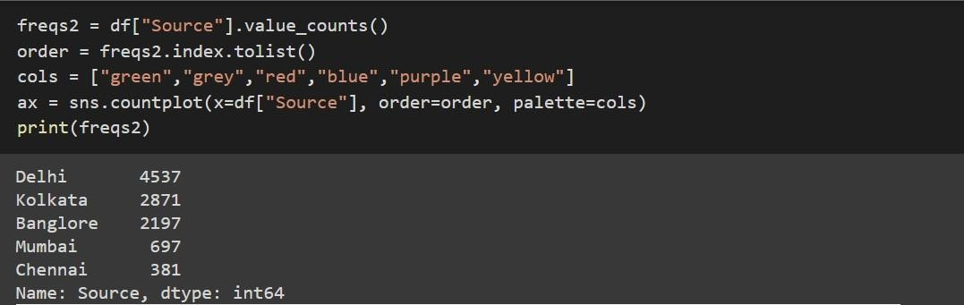

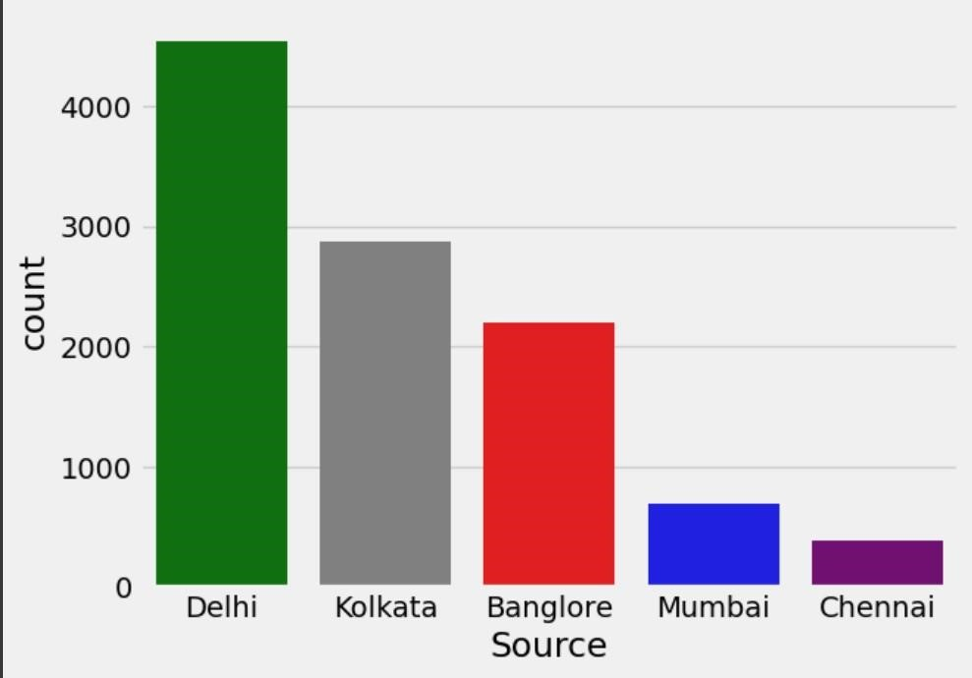

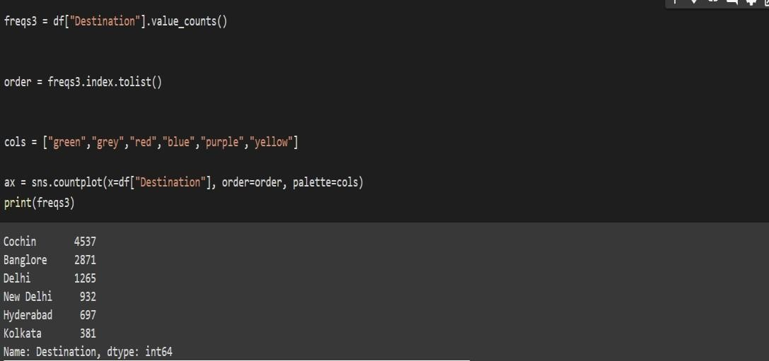

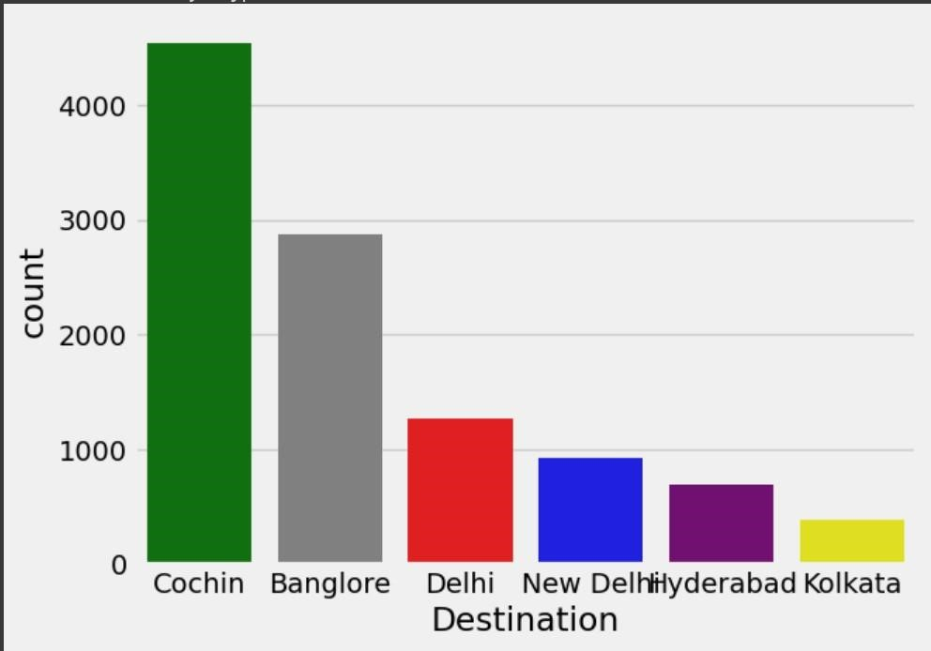

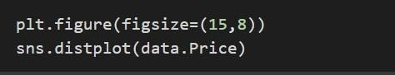

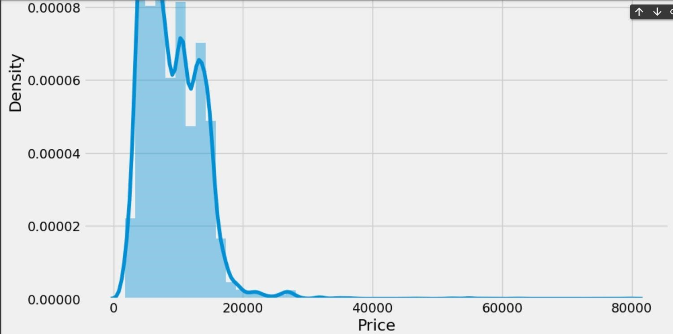



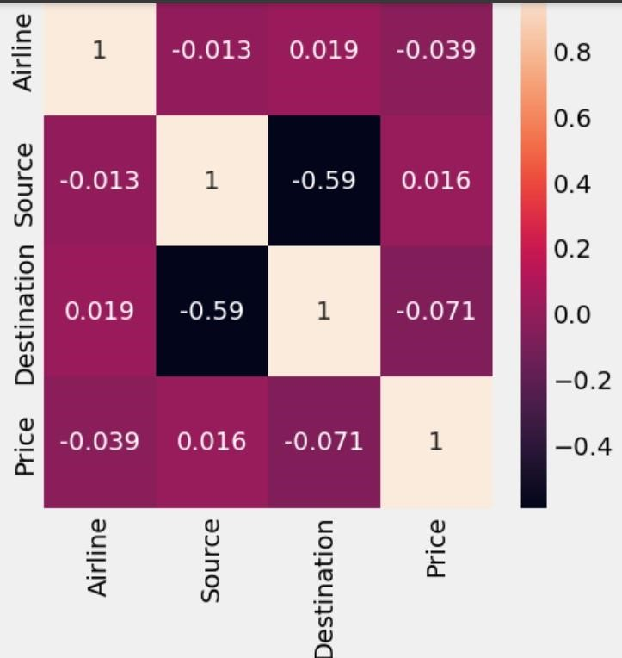

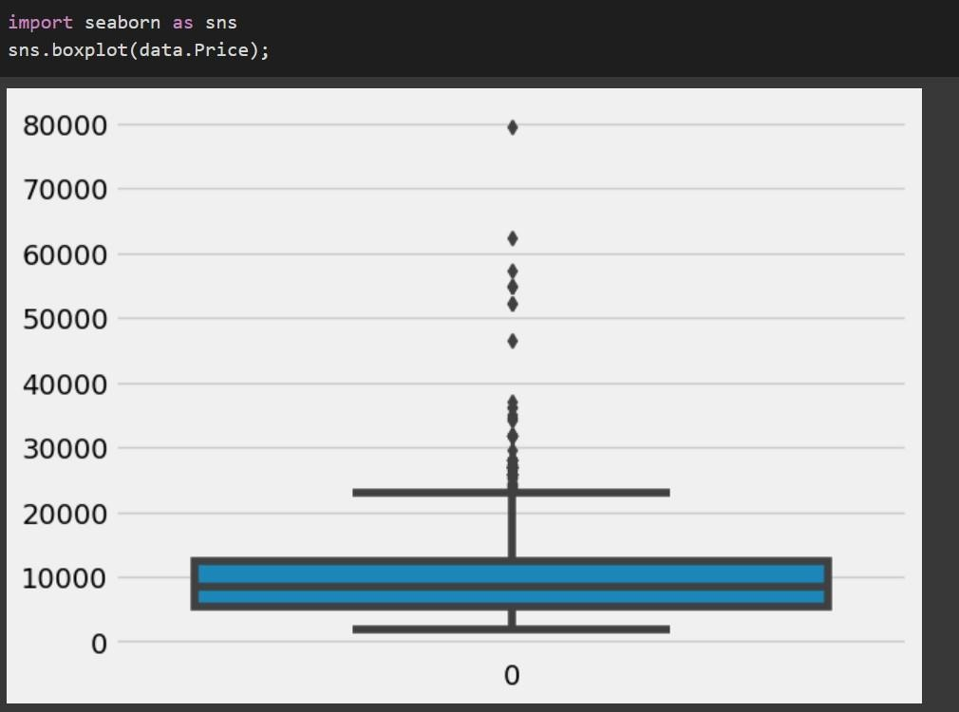

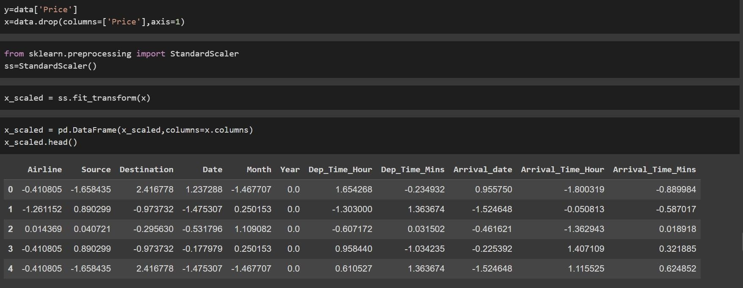

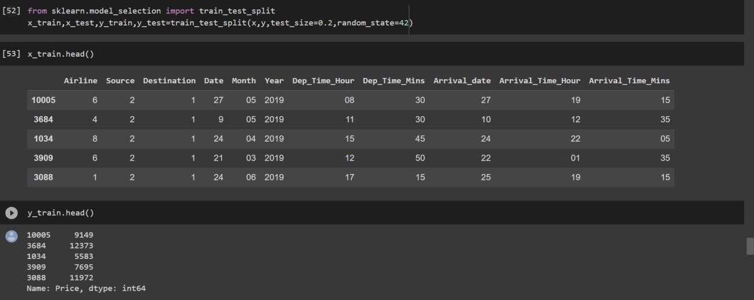

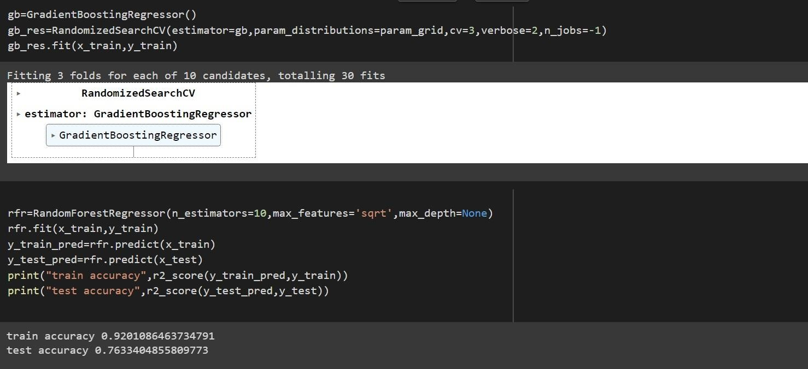

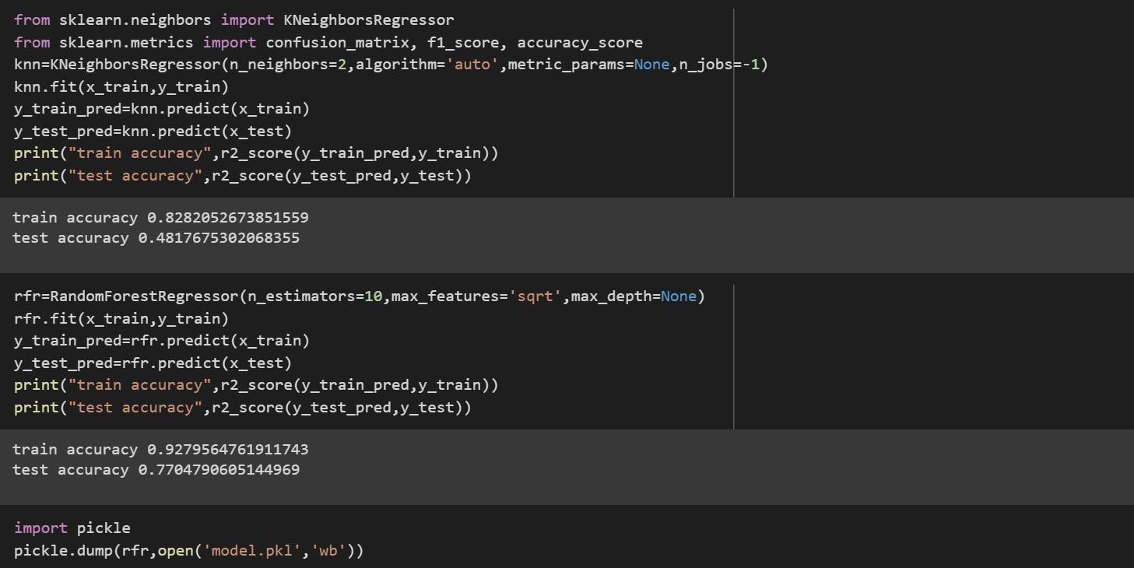

Home.html

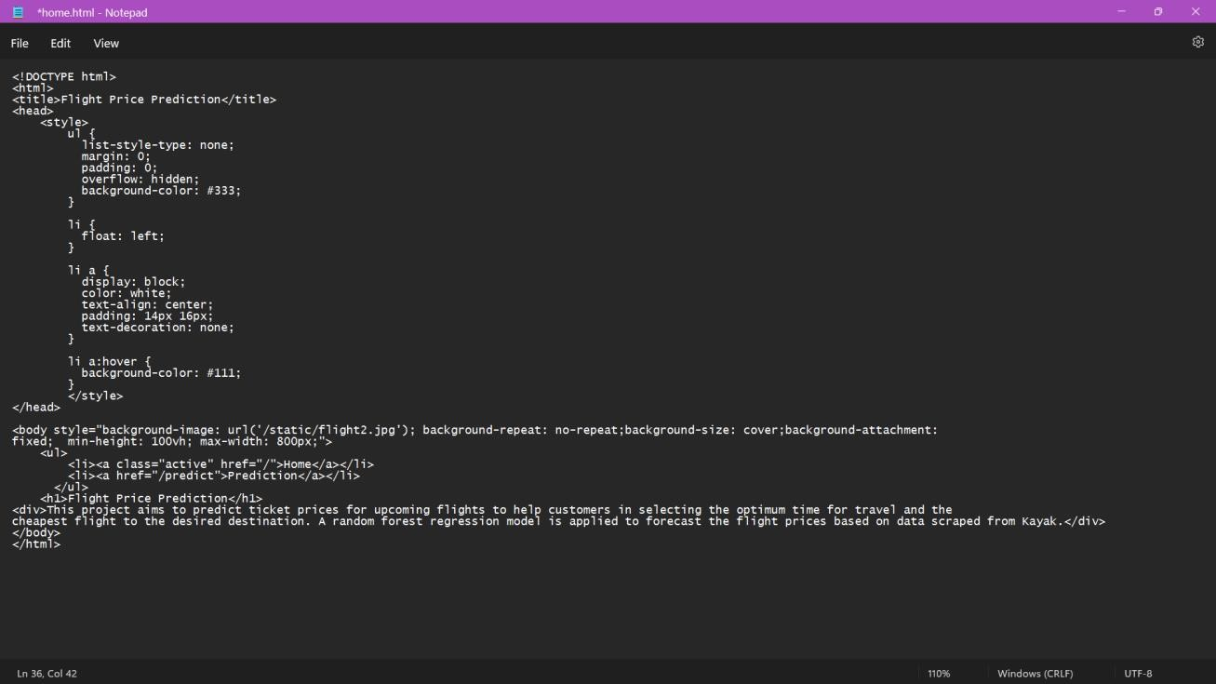

Predict.html

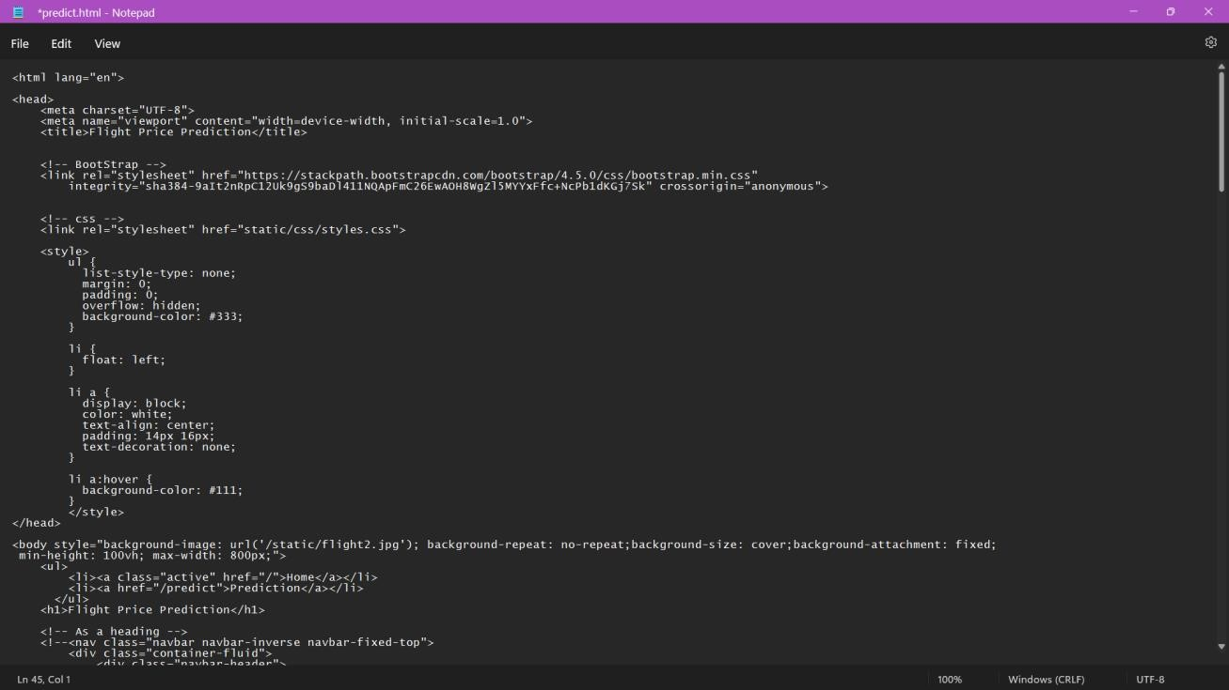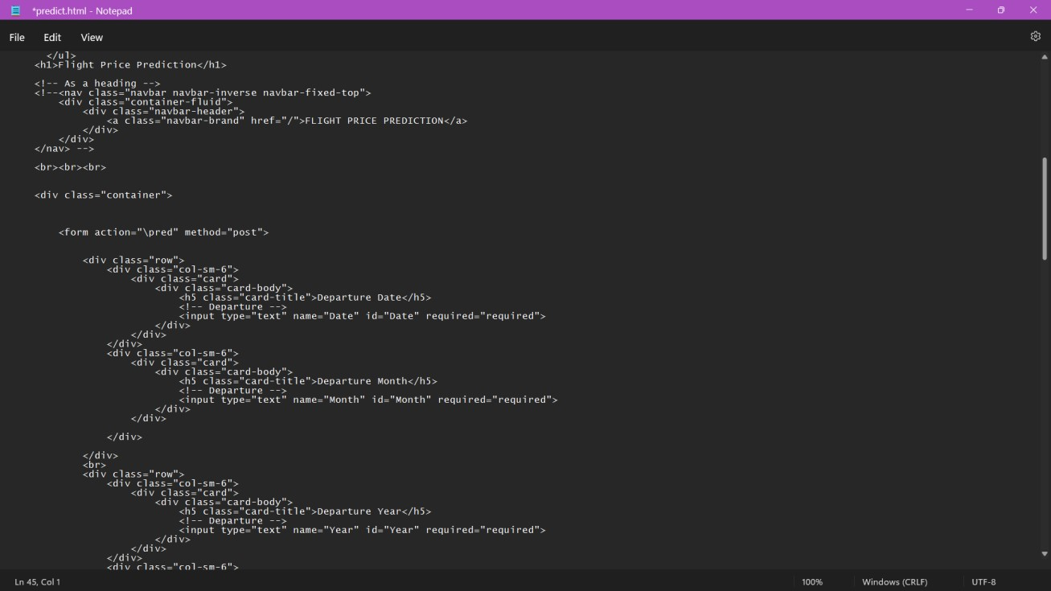

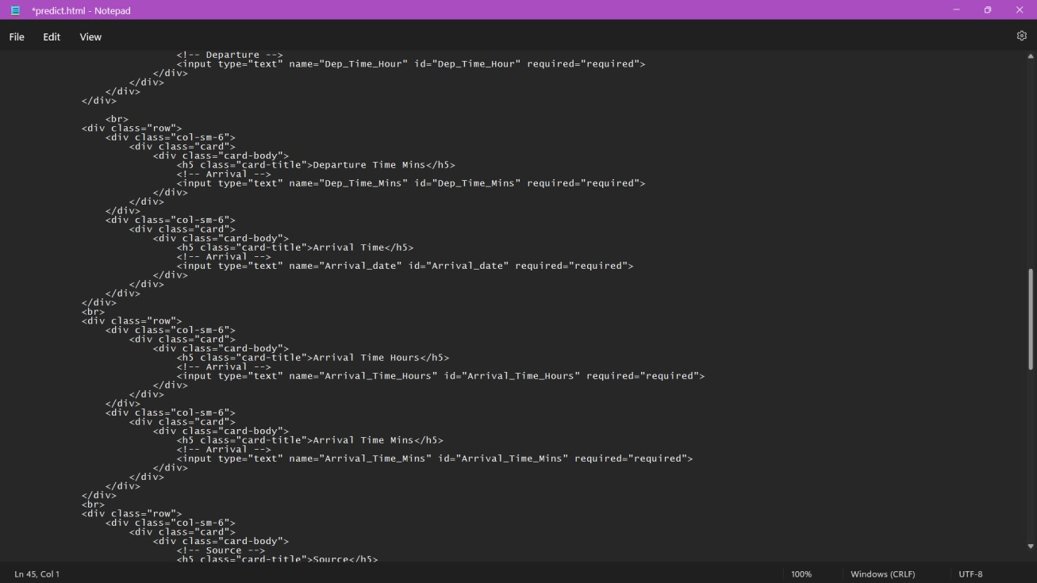

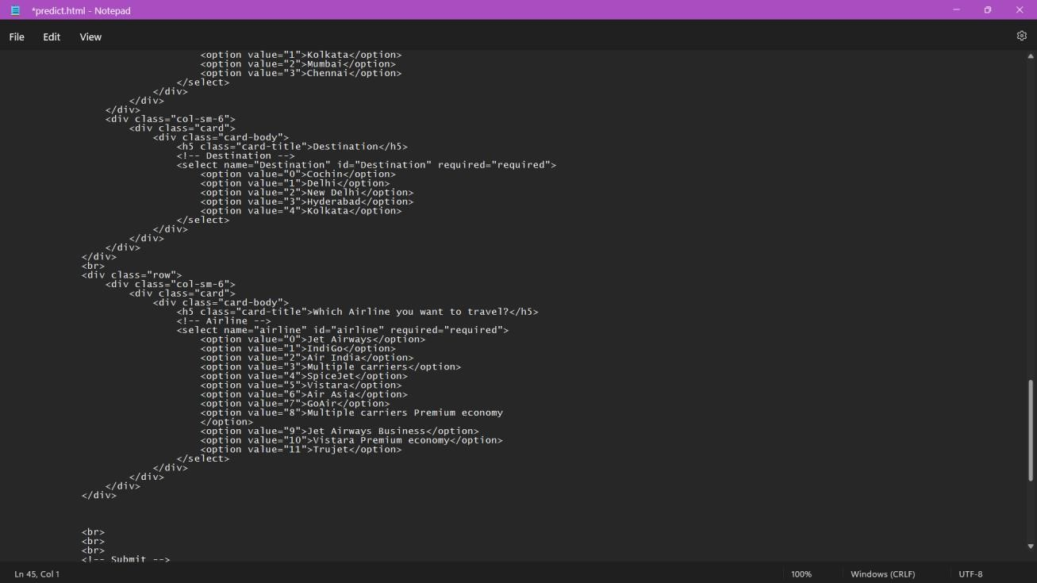

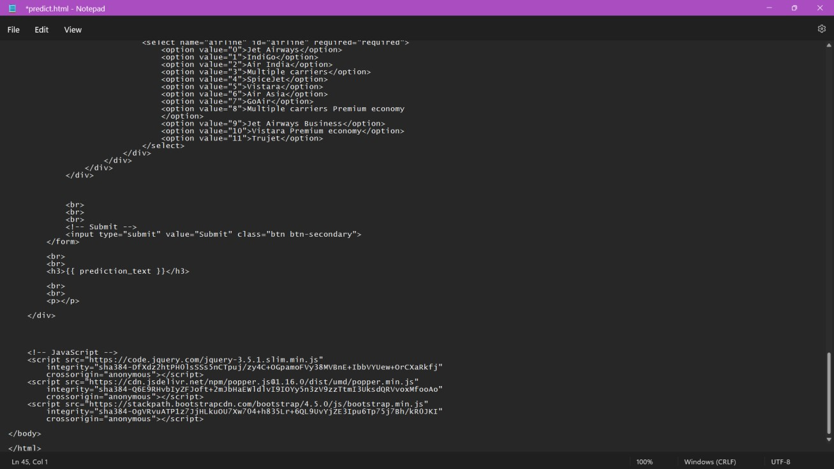

Submit.html

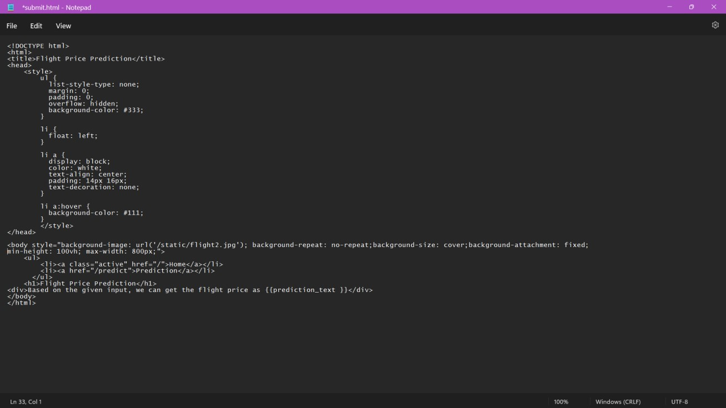

App.py

